# **Content**

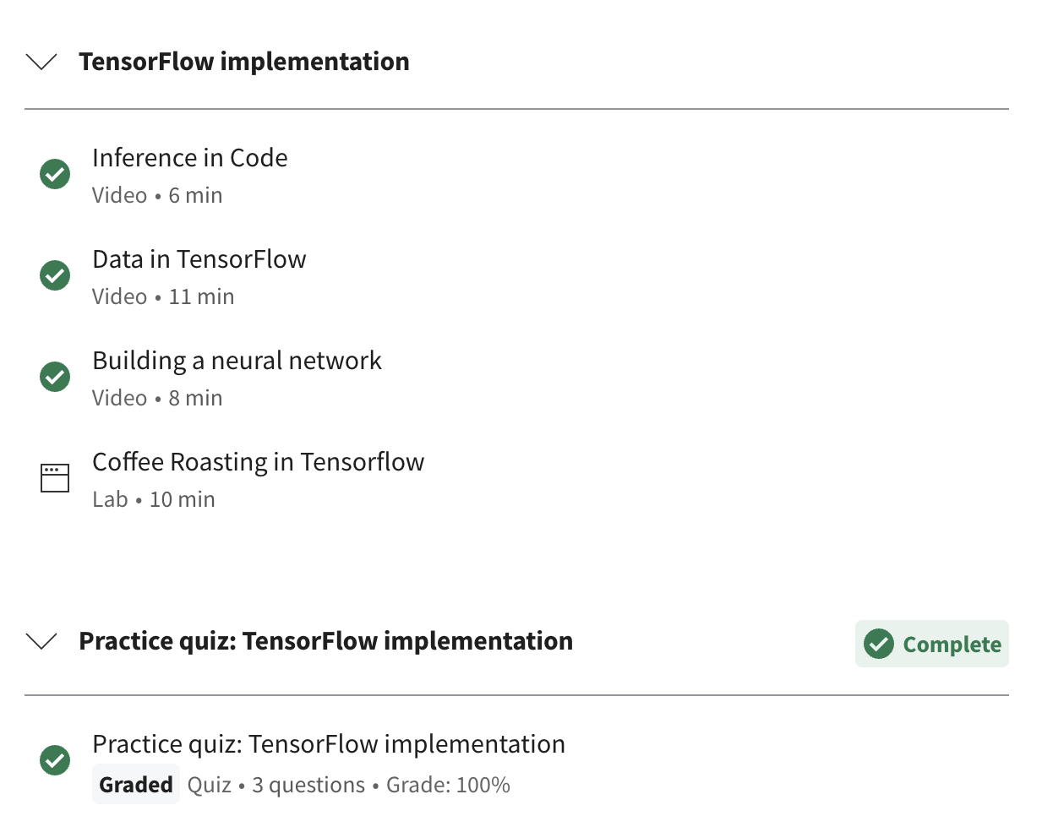

# **Inference in Code**

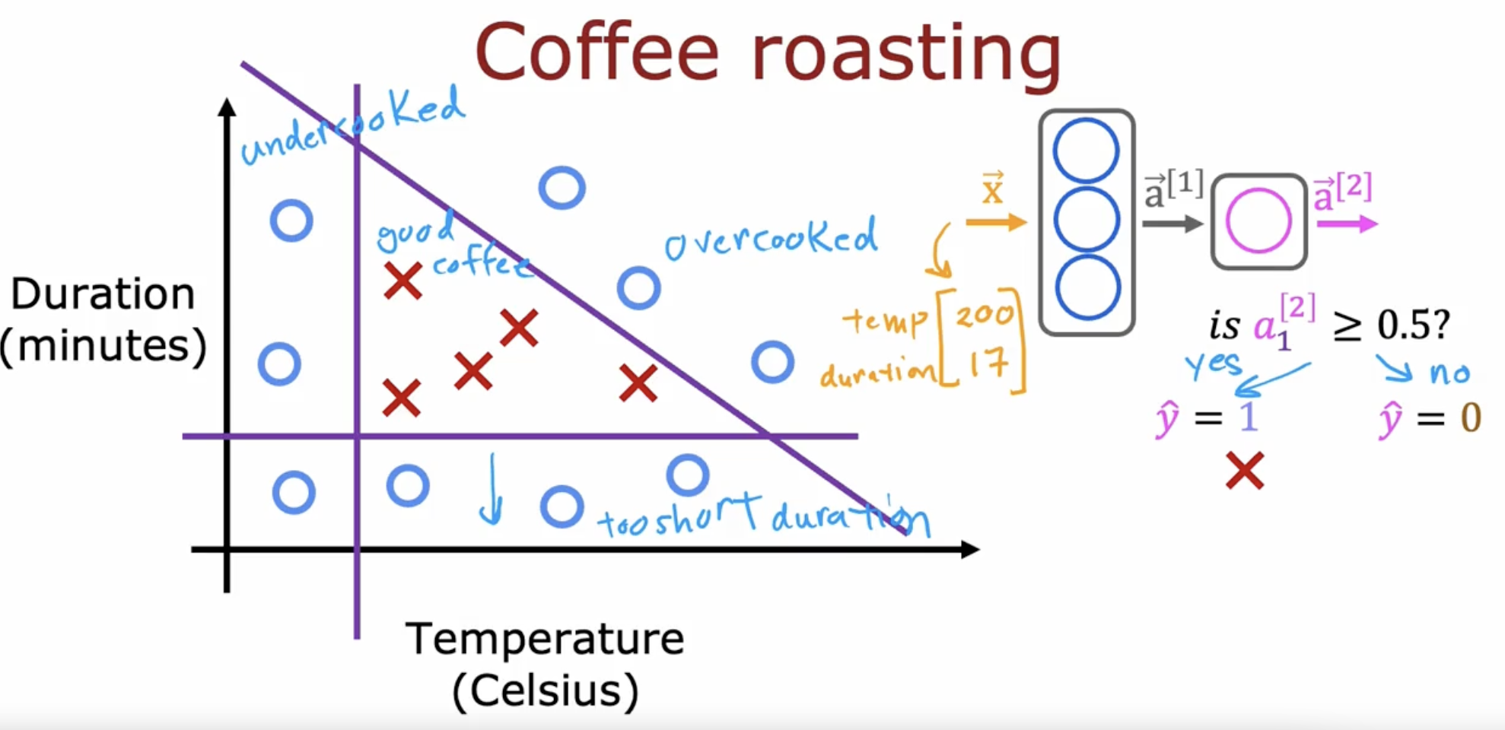

Less temperature and duration 🡪 undercooked

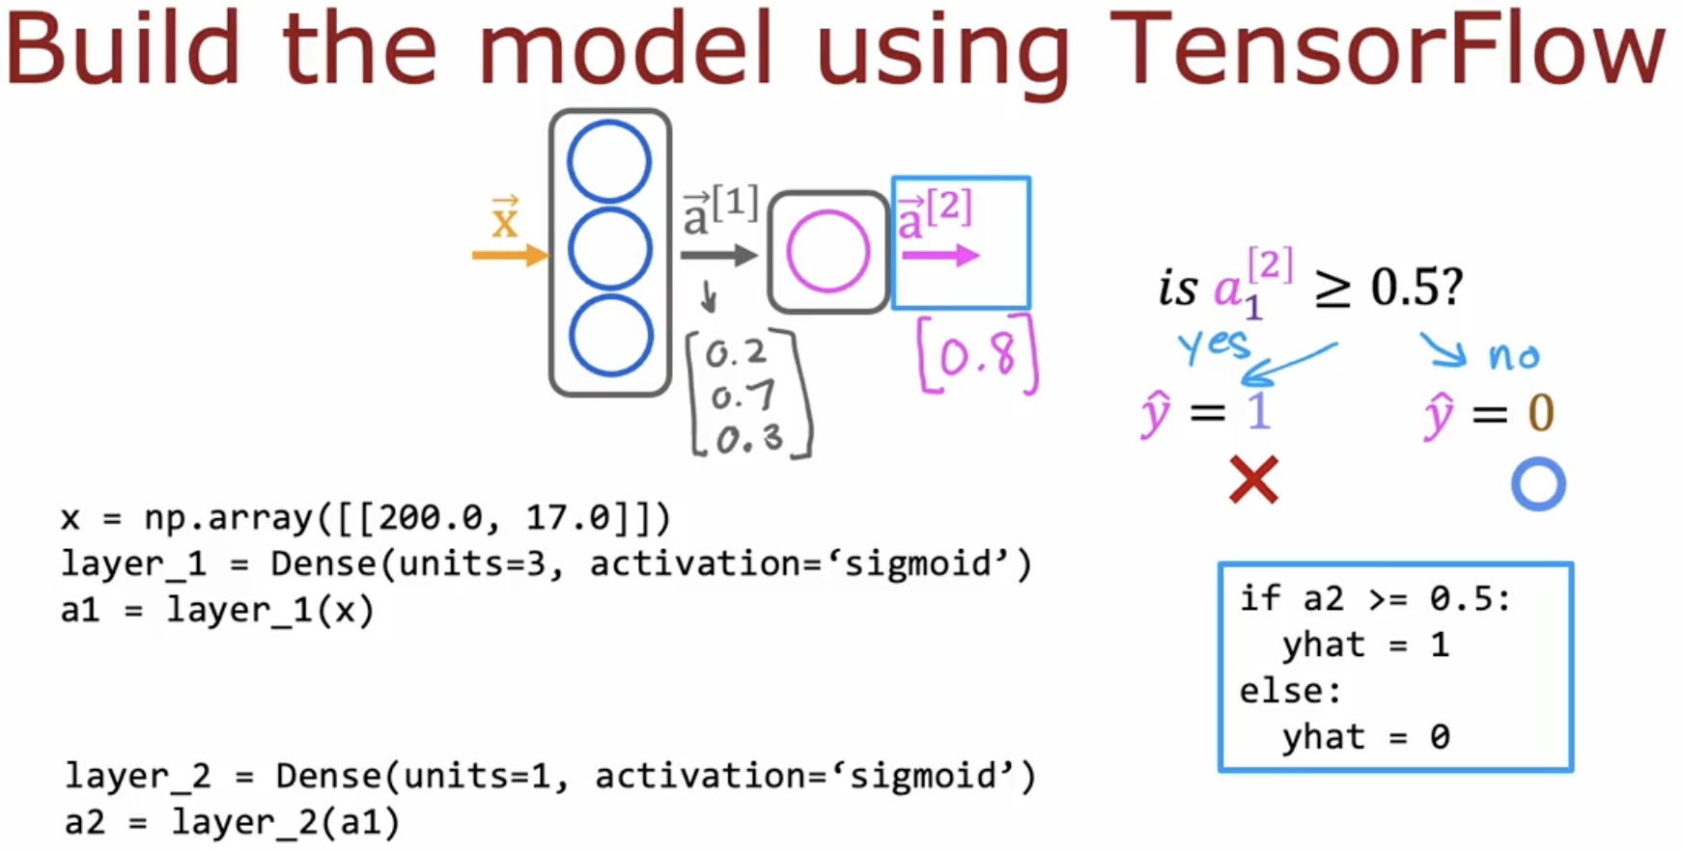

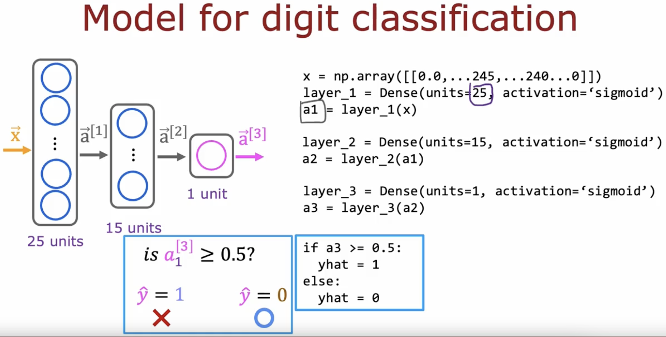

# **Data in TensorFlow**

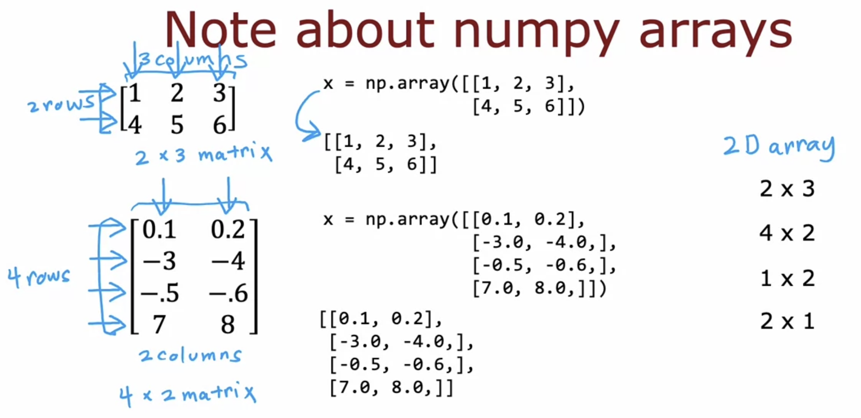

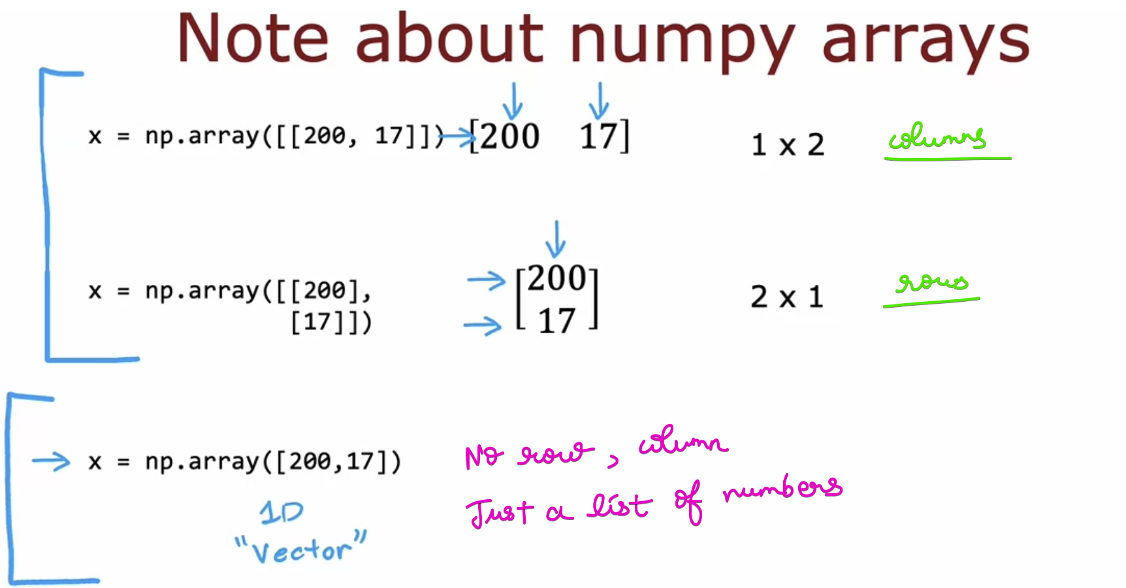

Coming back to our example

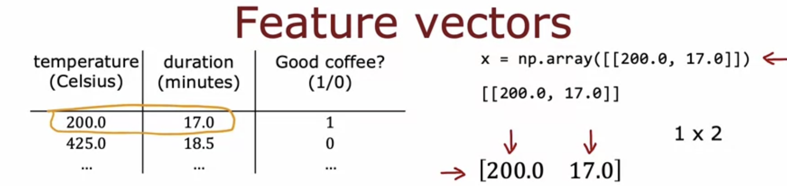

**For the activation function a1**

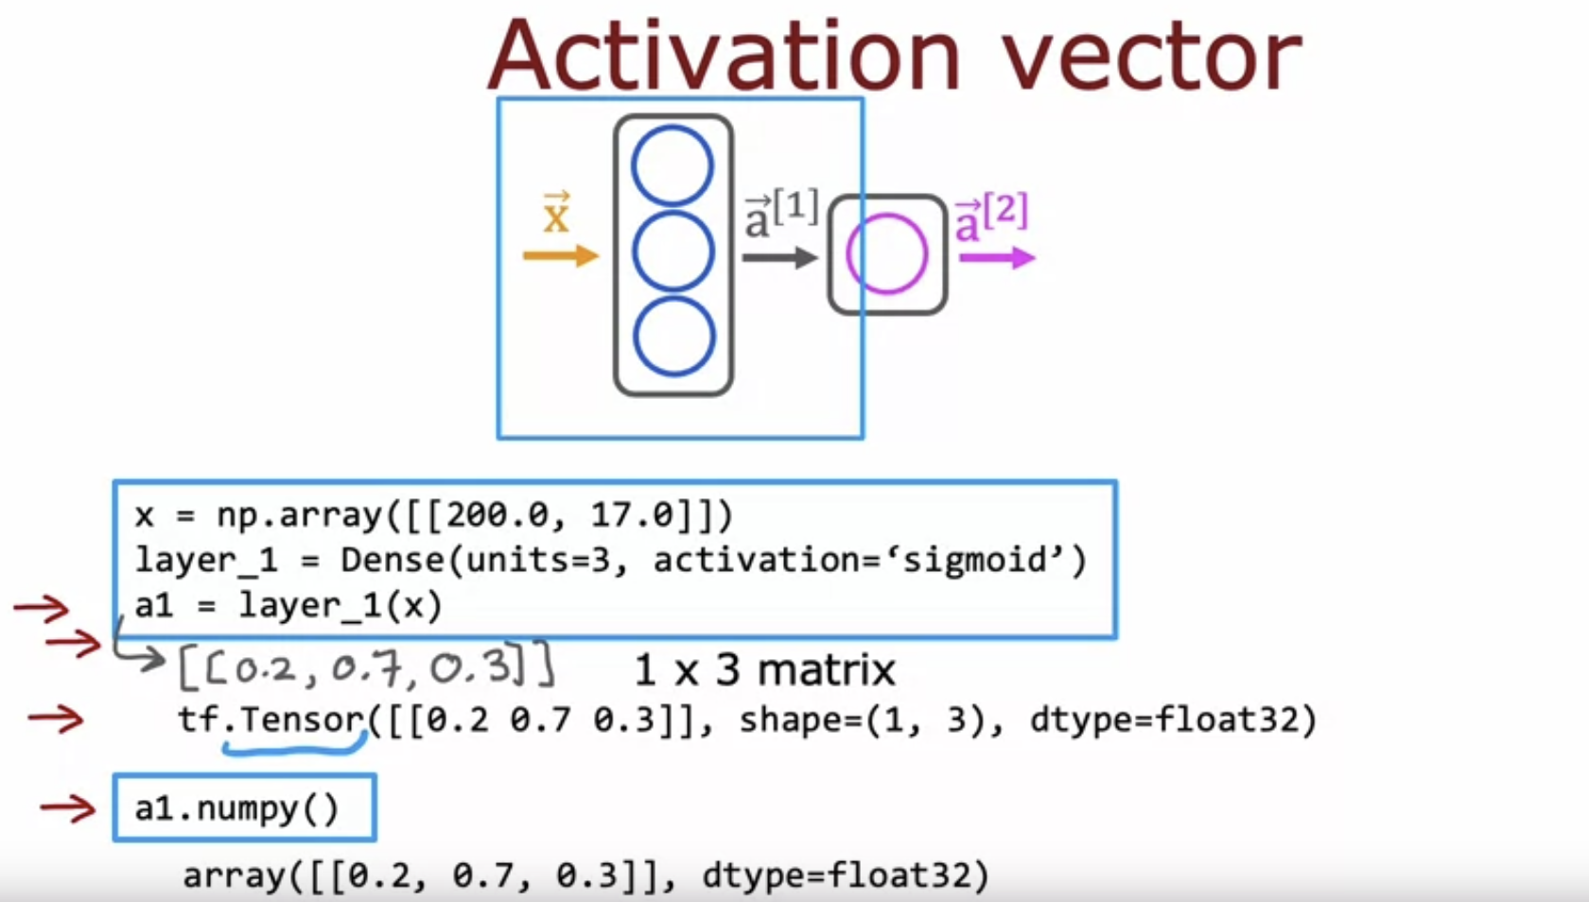

**For the activation function a2**

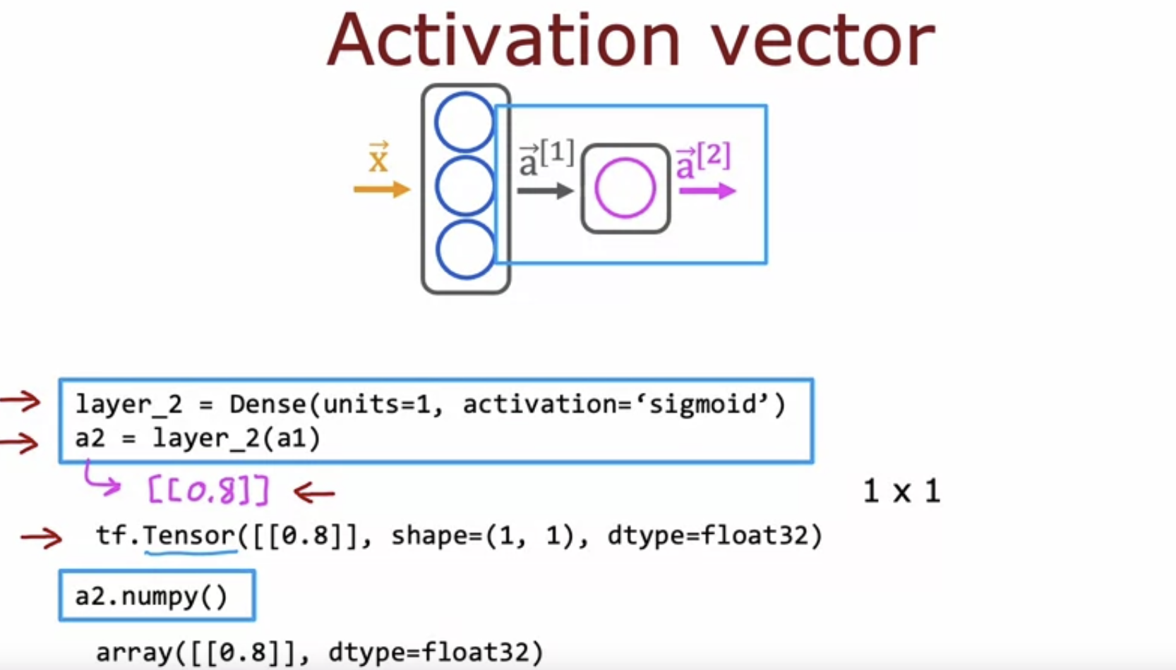

A tensor here is a data type that the TensorFlow team had created in order to store and carry out computations on matrices efficiently.

Think of tensors as a way of representing matrices.

There is a TensorFlow of representing a matrix and   
NumPy way of representing a matrix.

NumPy array to TensorFlow and vice versa is possible.

Tensor-flow way of representing **a2 = layer_2(a1)**

NumPy way of representing **a2.numpy()**

# **Building a Neural Network**

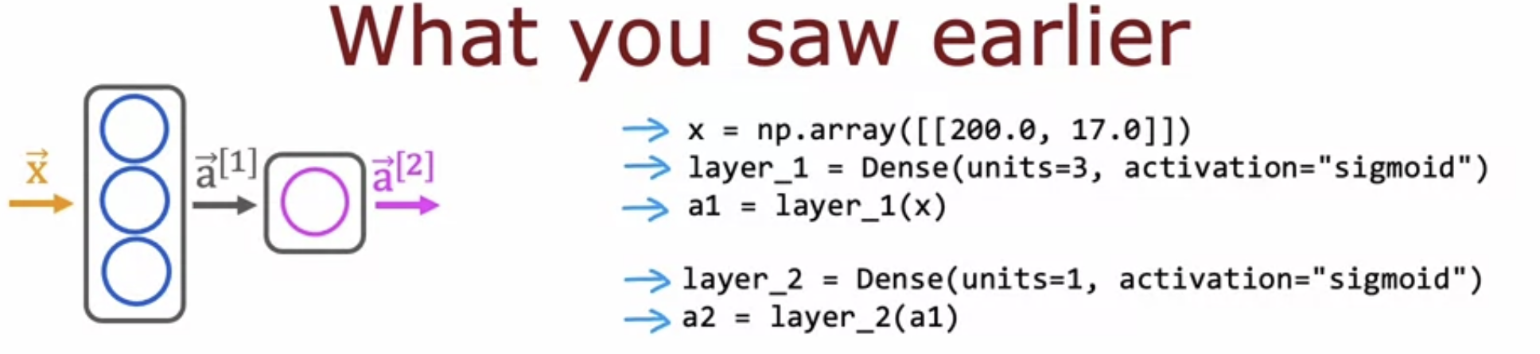

NumPy array 🡪 TensorFlow matrix

But now instead of you manually taking the data and passing it to layer one and then taking the activations from layer one and pass it to layer two.

We can instead tell tensor flow that we would like it to take layer one and layer two and string them together to form a neural network.

That's what the sequential function in TensorFlow does which is it says, Dear TensorFlow, please create a neural network for me by sequentially string together these two layers that I just created.

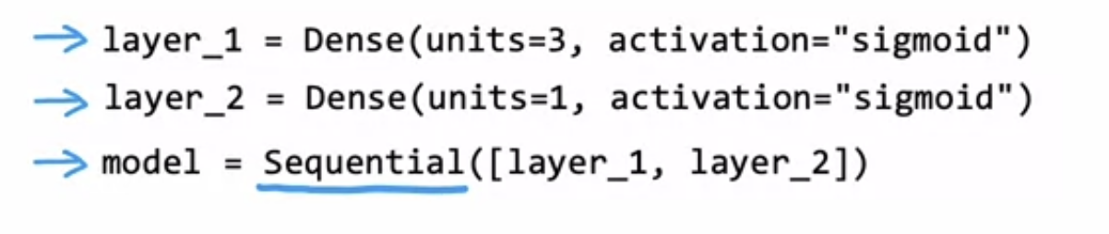

How do you do forward prop if you have a new example, say X new, which is NP array with these two features than to carry out forward propagation instead of having to do it one layer at a time yourself, you just have to call model predict on X new and this will output the corresponding value of a two for you given this input value of X.

So model predicts carries out forward propagation and carries an inference for you, using this neural network that you compiled using the sequential function.



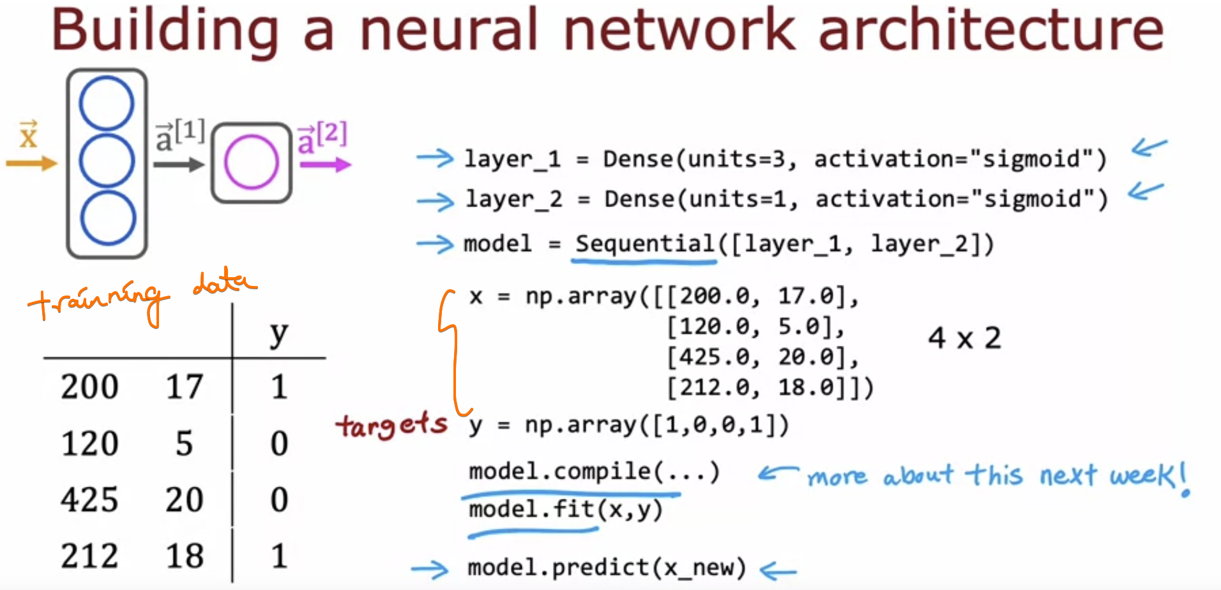

**So model predicts carries out forward propagation and carries an inference for you,   
using this neural network that you compiled using the sequential function.**

Combining layer-1 and layer-2 into model

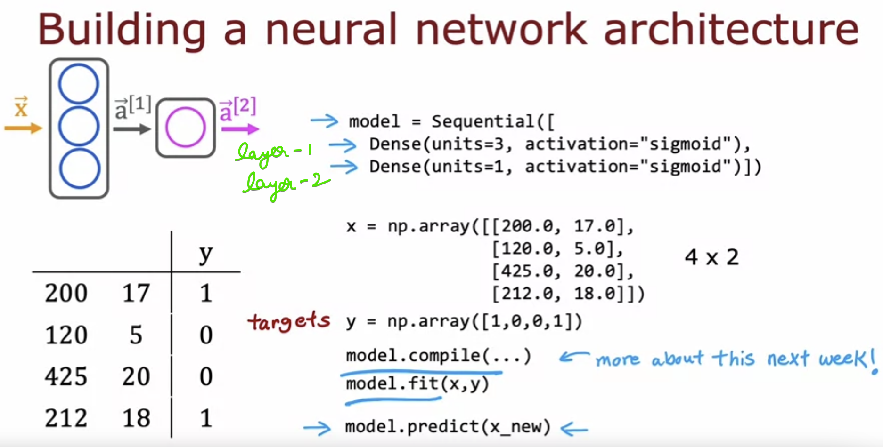

Lets take our Coffee Roasting example problem  
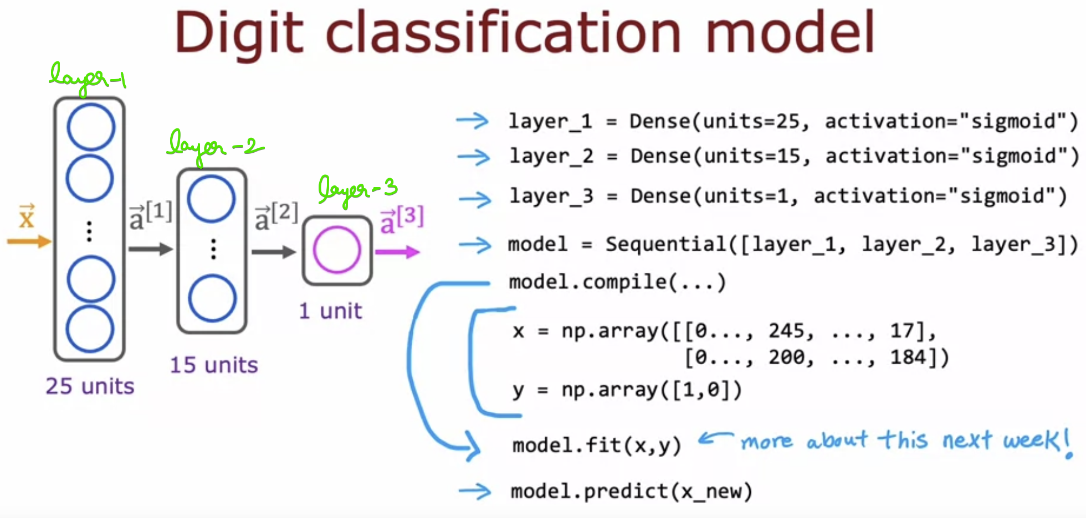

# **LAB 🡪 Coffee Roasting in TensorFlow**

Refer 2_CoffeeRoasting_TensorFlow.ipynb

# **Quiz**

